**9h45 – 10h30**

**9h30 – 10h15**

**9h30 – 10h15**

STEP2

**9h30 – 10h15**

**9h30 – 10h15**

SPECIAL BOOTY

DIMANCHE

SAMEDI

VENDREDI

MERCREDI

JEUDI

MARDI

LUNDI

BODYBARRE

ABDOSFLASH

PILATES

POSTURAL SHAPE

ABDOSFLASH

CAF

YOGA

CAF

**9h30 – 10h30**

**10h15 – 11h**

**10h30 – 11h15**

**10h15 – 10h30**

**10h15 – 10h30**

BODYZEN

CIRCUIT MINCEUR

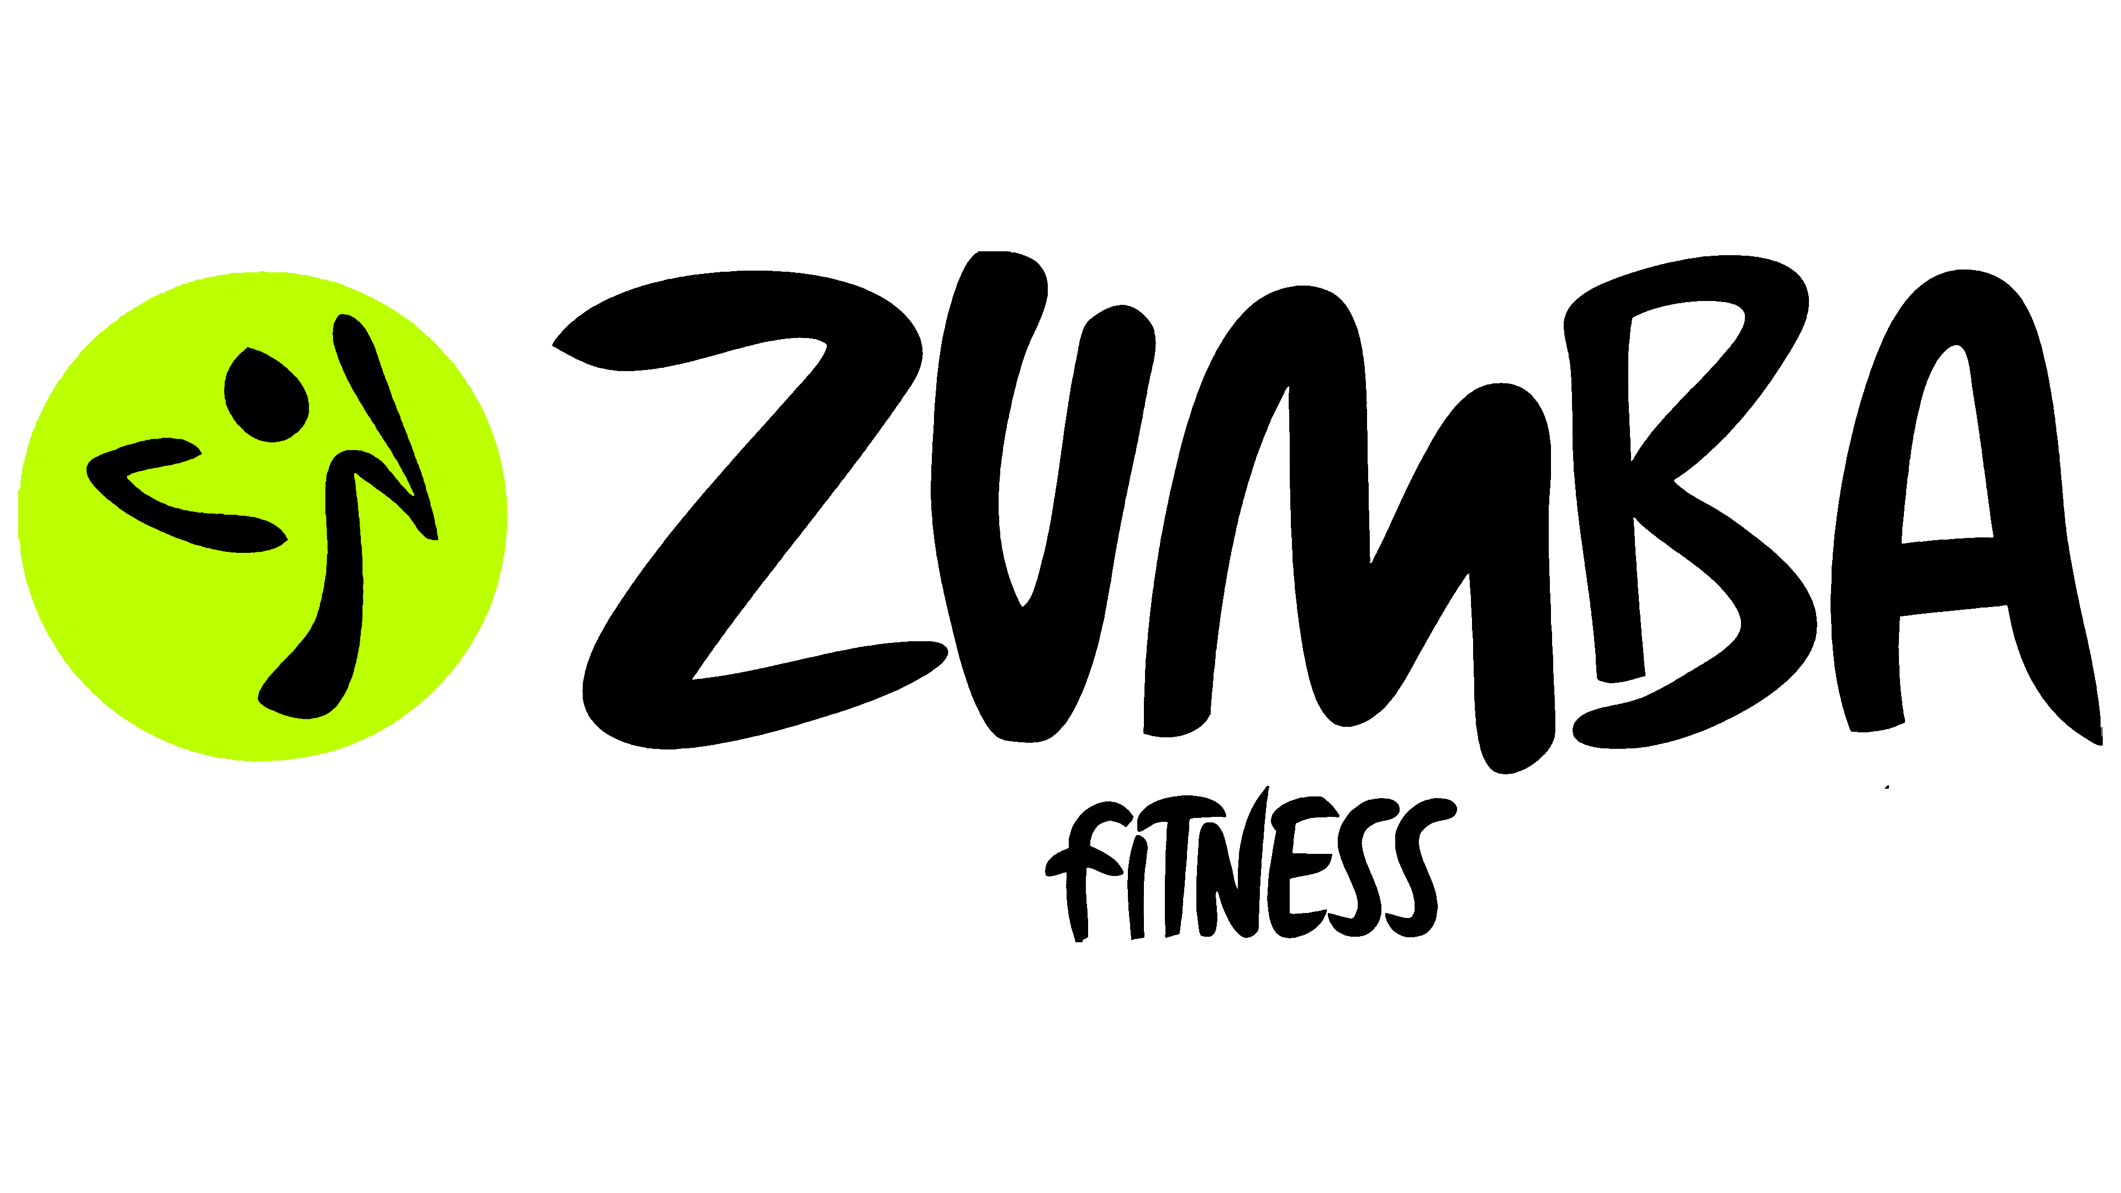

COMBAT

RENFO

CARDIO

GYM DOUCE

DANSE

CARDIO

RENFO

LEGENDE

**14h30 – 15h**

**15h - 15h30**

ABDOSFESSIERS

TAYOXING

**14h - 14h30**

**20h30 -21h15**

**20h30 – 21h30**

AFRO FIT

**19h – 19h45**

YOGASTRETCH

**18h30 – 19h**

BODYGLIDE

WOD

**20h30 – 21h30**

**10h30 – 11h30**

PILATES

**11h30 – 12h**

**19h30 – 20h30**

**19h30 – 20h15**

**18h45 – 19h30**

**18h – 18h45**

**20h – 21h**

**19h15 – 20h**

**18h30 – 19h15**

**18h – 18h30**

**19h45 – 20h30**

**19h15 – 19h45**

**18h30 – 19h15**

**19h45 – 20h30**

**19h15 – 19h45**

**18h30 – 19h15**

**11h30 – 12h30**

**11h - 11h30**

**12h30 – 13h30**

**12h30 – 13h**

**11h45 – 12h30**

**11h15 – 11h45**

**13h – 13h15**

**12h15 – 13h**

**11h – 11h45**

**10h15 – 11h**

**10h30 – 12h**

**12h15 – 13h**

**11h – 11h45**

**10h30 – 11h**

**10h15 – 11h00**

**11h00 – 11h45**

FITBALL

BIKING

**IKING**

CIRCUITTRAINING

YOGA

ABDOSFESSIERS

PILATES

BODYGLIDE

ABDOSFLASH

GRITCARDIO

TRX

STRETCHING

YOGA

GYM SUEDOISE

FITBALL

PILATES

PILATES

STRETCHING

TBC

CROSSTRX

STEP 1

BIKESPRINT

STRETCHING

BODYZEN

MAGICPUMP

STEP 2

CAF

BIKING

**ING**